September Specials

Soup of the Month: Acorn & Butternut Squash
Seasonal Vegetable of the Month: Mushrooms
- Sautéed bacon, mushrooms, & onions
- Beer battered mushroom slices
- Roasted balsamic mushrooms
Dessert of the Month: Macadamia Nut & White Chocolate Cookies

September 2nd- Celebrate Cheese Pizza Day!
CHEESE CALZONES $8/ with salad or ONE side $10

September 9th- It’s National Vegetarian Awareness Week!
FALAFEL QUINOA BOWL ($14)
Variety of squashes, onions, and garlic roasted with Mediterranean herbs & spices. Then served on a bed of quinoa, black olives, fresh tomatoes & cucumbers, shredded lettuce, and topped with baked falafel. Served with vinaigrette.

September 16th- Chinese Takeout
HONEY GARLIC CHICKEN ($10)
Tempura battered white meat chicken coated in Chef’s honey-garlic sauce and served with egg fried rice, and steamed Asian style vegetables.

September 23rd- Rosh Hashanah 2019! L’shanah Tovah!
CHEF’S TRADTION ($15)
Traditional beef brisket in gravy, tzimmes (roasted carrots, sweet potato), apple & sweet onion kugel, and sliced challah bread with apples & honey for dipping

September 30th- Florida Fresh Mushroom
BAKED STUFFED PORTOBELLA ($12)
Simple mix of sausage, celery, onions, & herbs topped with parmesan bread crumbs with vegetable rice

October Specials

Soup of the Month: Blood Red Moon Soup - Red Pepper & Gouda
Seasonal Vegetable of the Month: Yellow Squash
- Cheesy squash casserole
- Mediterranean tomato, squash, eggplant, onions, and herbs
- Steamed drizzled with garlic oil
Dessert of the Month: Worms in Dirt Cups- layers of chocolate pudding, chocolate whipped cream, crushed chocolate cream cookies, and gummy worms

October 7th: Mummified & Baked
STEAK WELLINGTON ($14)
Seasoned steaked topped with sautéed mushrooms, onion, & garlic. Then wrapped in dough and baked until golden. Accompanied by beef gravy, roasted asparagus, and parmesan red mashed potato

October 14th: A Giants Finger
CHICKEN PARMESAN ROLL ($12)
Fresh mozzarella rolled in a chicken breast, breaded, and baked. Served with tomato sauce, spaghetti, and garlic buttered broccoli

October 21st: The Bewitched Hog
ENGLISH MUSTARD PORK ($14)
Pork loin marinated in English ale, mustard seeds, fresh herbs, & other savory seasonings; then baked with brioche butter crust. Sides include potato au gratin and glazed carrots

October 28th: Jack-o-Lanterns
STUFFED BELL PEPPERS ($12)
A set of carved orange peppers stuffed with herbed ground beef, garlic rice, shredded cheese, and seasonal vegetables. Baked in tomato sauce.

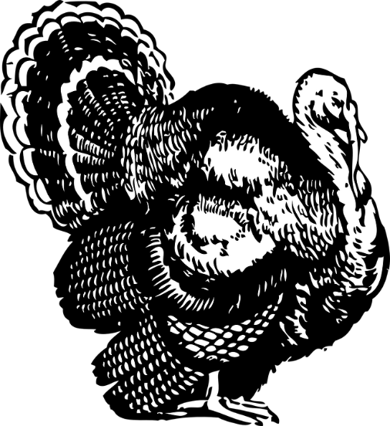
November Specials

Vegetable of the Month: It’s Sweet Potato Awareness Month!
- Baked potato (pick side of butter, cinnamon-sugar butter, or plain)
- Casserole style with marshmallow topping
- Baked wedges dusted with smoky chili seasoning
Soup of the Month: Split Pea
Desserts of the Month: Cinnamon Apple Turnovers, Pumpkin Pie

November 4th: CLOSED

November 11th: I Love Figs Week!
LOVE BIRD PUFFS ($12)
Our Adobo chicken breast shredded in layers of Gouda cheese, fig jam, and stuffed into puff pastry. Accompanied with butter brandy green beans

November 18th: Florida’s Catch of Day
SWEET POTATO & COCONUT CRUSTED CHOICE FISH ($12)
Pan-fried and served with key lime tartar, garlic rice, and sautéed green beans with bacon

November 25th: Celebrate Thanksgiving with Foodism!
HOME-STYLE THANKSGIVING ($16)
Brined turkey roasted with lemon-herb butter, yeast rolls, and fresh cranberry-apple sauce.
Choose TWO sides: creamed corn, red potato mash, German sausage stuffing, butter & herbs stuffing, green beans & bacon in brandy butter, rice pilaf
Pick Your Dessert: Cinnamon Apple Turnovers, Pumpkin Pie, Sweet Potato Crème Brulee

December Special

Seasonal Vegetable of the Month: Broccoli
- Steamed with garlic parmesan butter
- Roasted with onions, zucchini, and carrots
- Battered & fried
Soup of the Month: Broccoli Cheddar
Desserts of the Month: Eggnog Crème Brulee, Peppermint Bark Dipped Pretzels, Sufganivot

December 2nd: Italian Chicken Florentine
PICK YOUR FAVORITE ($12):
- Spinach & shallot stuffed seasoned chicken breast, slowly roasted in broth and white wine. Then topped with creamy parmesan sauce with a side of mashed potatoes
- Sliced roasted chicken breast, sautéed spinach & shallot on a bed of fettuccini pasta tossed in creamy parmesan sauce

December 9th: Happy Hanukkah!!
Prix Fixe Menu ($16)
Course 1: Matzo ball soup
Course 2: Slow roasted brisket in red wine accompanied by roasted root vegetables, potato latkes
Course 3: Sufganivot

December 16th: Merry Christmas!!
FAMILY DINNER ($16)
Spiral ham coated with classic pineapple-maple glaze, yeast rolls, and cranberry-apple sauce
Choose TWO sides: creamed corn, red potato mash, German sausage stuffing, butter & herbs stuffing, green beans & bacon in brandy butter, rice pilaf
Dessert: Eggnog crème brulee

December 23rd: CLOSED
December 30th: CLOSED

